# Supplementary material

# Title: Maximizing buckling load of metabeams via combinatorial optimization of microstructures

**S1: Data preparation and surrogate model building.**

We sampled 20 independent variables in Matlab by using the Latin Hypercube method, and a total of 20,000 samples were sampled in the sample space. After calculating through ABAQUS and deleting some abnormal data, a total of 19958 sets of valid data were obtained. The neural network machine learning model was built in Matlab with a structure of [20, 64, 1], which means that the neural network has 20 inputs, 1 output and one hidden layer with 64 neurons. 70% of the dataset is divided into training sets and 30% divided into test sets. The activation function was the Sigmoid function and the training algorithm was the Levenberg-Marquardt method.

**S3: Material characterization and experiment**

Fig.S1(a) and Fig.S1(b) show instruments and chucks for compression testing, respectively. Specimens for compression testing are shown as Fig.S1(c). A is the initial design and B is the optimal design. The ends of the specimens are extended by 15 mm on the basis of the original structure, which is designed for easy clamping. The thickness of the specimens is set to 40mm. The material used in the preparation of the sample is a soft rubber material similar to silica gel, and the preparation method is laminated process. The specimen used to test the material parameters is shown in Fig.S2(a). It is prepared according to the CHINA national tensile test standard. Fig.S2(b) shows its stress-strain curve, and the tensile loading speed is 20mm/s. Since the experiment cannot limit the deformation outside the surface of the beam, a three-dimensional finite element model is used when comparing with the experimental results, and the sizes are consistent with the experiment.

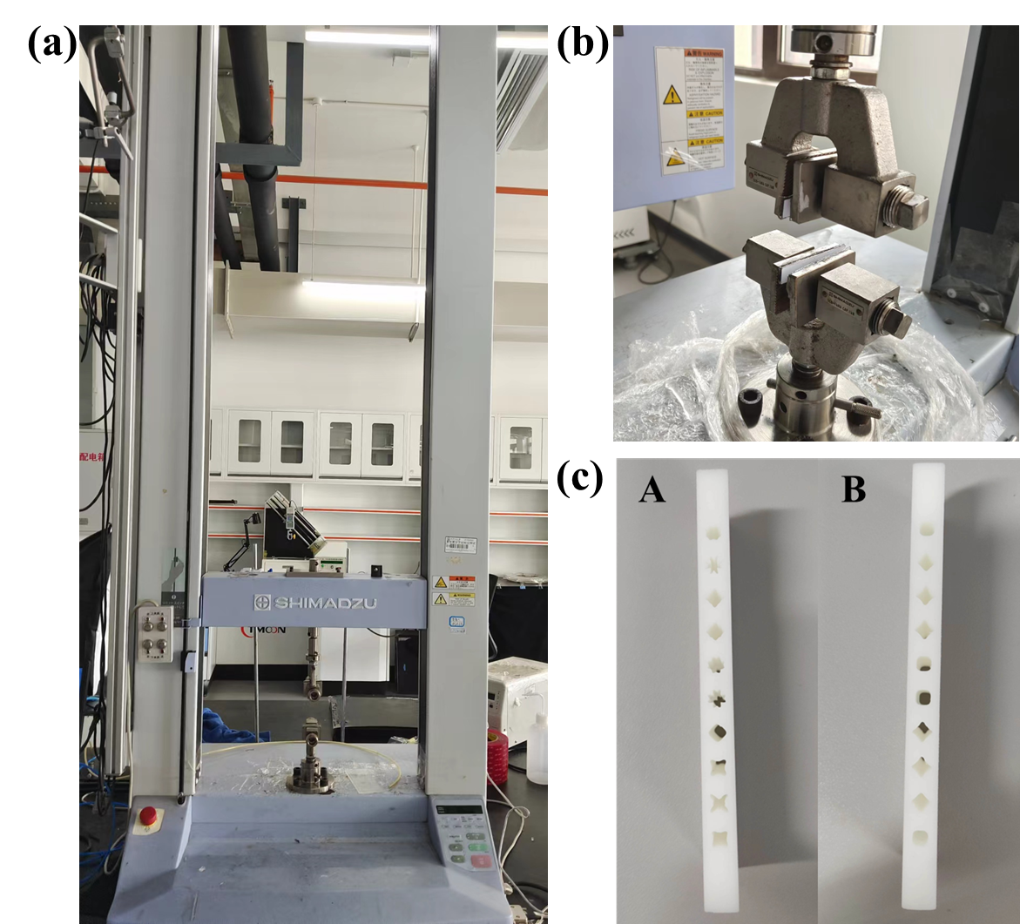

FIG.S1 (a) Tensile testing machine used in the laboratory. (b) The chuck used for the experiment. (c) Compression samples used for the experiment.

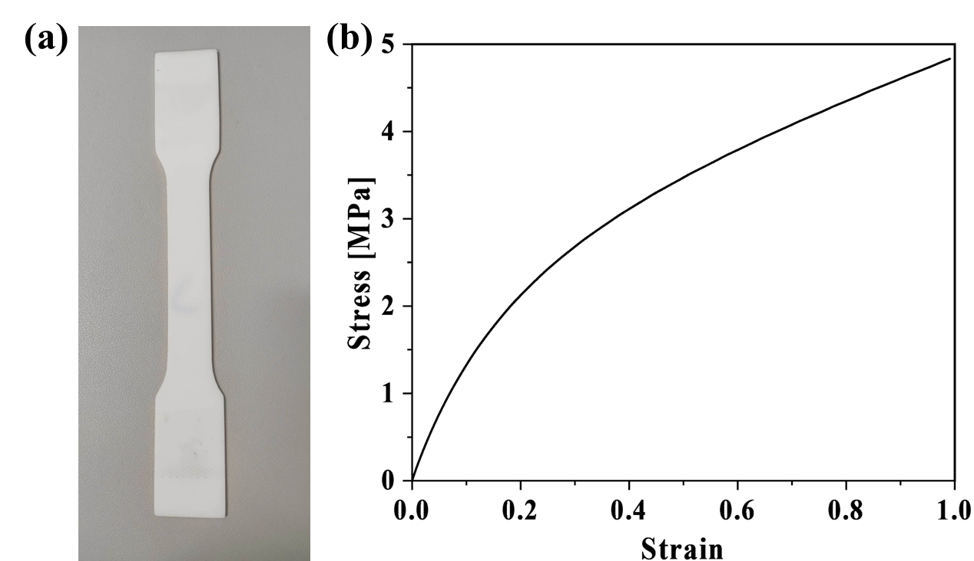

FIG.S1 (a) Standard tensile parts for testing material parameters. (b) Tensile stress-strain curve.